**DUYTAN UNIVERSITY**

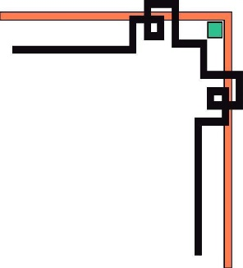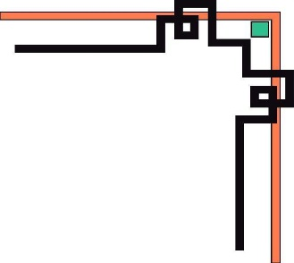

**INTERNATIONAL SCHOOL**

**--------------🙖🙐✰🙖🙐-------------**



**CMU-SE 100**

**INTRODUCTION TO SOFTWARE ENGINEERING**

**SYNTHESIS REPORT GROUP PROJECT**



**Mentor: Msc. Huy Nguyen Dang Quang**

***Team Member*:**

**Tuan, Nguyen Dinh(Leader)**

**Quyen, Le Huu**

**Phi, Nguyen Dinh**

**Huy,Than Quang**

**Trong,Tran Nguyen Huu**

**Group Project - Mentor:**

Name: Signature: Date:

Da nang, 12/2023

**PROJECT INFORMATION**

|  |  |
| --- | --- |
| **Project Acronym** | NNC |
| **Project Title** | Cafe Management System | | | |
| **Start Date** | 12/3 | **End Date** | 12/25 | |
| **Lead Institution** | International School, Duy Tan University | | | |
| **Team Member** | **Name** | **Email** | | **Phone** |
| 28211280315 | Nguyễn Đình Tuấn | nguyendinhtuancf2@gmail.com | | 0379676303 |
| 29211155174 | Lê Hữu Quyền | [lehuuquyen18092004@gmail.com](mailto:lehuuquyen18092004@gmail.com) | | 0905353824 |
| 29211355447 | Nguyễn Đình Phi | phinguyen18112005@gmail.com | | 0359575089 |
| 29211157231 | Thân Quang Huy | thanquanghuy2904@gmail.com | | 0387817183 |
| 29212254913 | Trần Nguyễn Hữu Trọng | trongtran34h@gmail.com | | 0395125027 |

**DOCUMENT NAME**

|  |  |  |  |
| --- | --- | --- | --- |
| **Document Title** | **Synthesis Report Group Project Document** | | |
| **Reporting Period** | 25 – Dec – 2023 | | |
| **Author(s)** | Tuấn,Quyền,Phi,Huy,Trọng | | |
| **Role** | Leader,Teammember,Teammember,Teammember,Teammember | | |
| **Date** | 12/3/23 | **Filename** | Team3_ CMU-SE-100_NNC |

**SIGNATURE**

***Document Approvals:*** *The following signatures are required for approval of this document.*

|  |  |  |  |
| --- | --- | --- | --- |
| **Mentor** | Huy, Nguyen Dang Quang | **Signature:** |  |
| **Date:** |  |
| **Team Lead** | Tuan,Nguyen Dinh | **Signature:** | Tuan Nguyen |
| **Date:** | 12/24/23 |
| **Team member(s)** | Quyen,Le Huu | **Signature:** | Quyen Le |
| **Date:** | 12/24/23 |
| Phi,Nguyen Dinh | **Signature:** | Phi Nguyen |
| **Date:** | 12/24/23 |
| Huy,Than Quang | **Signature:** | Huy Than |
| **Date:** | 12/24/23 |
| Trong,Tran Nguyen Huu | **Signature:** | Trong Tran |
| **Date:** | 12/24/23 |
|  | **Signature:** |  |
| **Date:** |  |

**REVISION HISTORY**

|  |  |  |
| --- | --- | --- |
| **Version** | **Date** | **Description** |
| **1.0** | 12/5/2023 | **Make document for project** |
| **1.1** | 12/8/2023 | **UI changes and updates** |
| **1.2** | 12/13/23 | **Change and update new drink genres** |
| **1.3** | 12/15/23 | **Upgrade search data on drink genres** |
| **1.3.1** | 12/17/23 | **Update the drink customers want** |
| **1.4** | 12/23/23 | **Fix the errors on the website that customers report** |

**TABLE OF CONTENTS**

**1. INTRODUCTION** 5

**2. DESCRIBE BUSINESS PROCESSES OF RESTAURANT** 5

**3. LIST OF PARTICIPANTS TO REQUIREMENTS GATHERING** 6

**4. THE TECHNICALS USING TO REQUIREMENTS GATHERING** 6

**5. ASSIGNMENT TEAM MEMBER TO REQUIREMENTS GATHERING** 7

**6. INTRODUCTION PROJECT** 10

**6.1. Project Objectives** 10

**6.2. Project Scope** 11

**6.3 Identify the Functional Requirement & Non-Functional Requirement** 12

**a) High level Functional Requirement (FR)** 12

**b) List of Non-Functional Requirement** 14

**7. THE USER REQUIREMENT ANALYSIS** 15

**7.1 Business Function Diagram** 15

**7.2 Context Model** 16

**a) Context Model** 16

**b) System Context Description** 16

**7.3 List of Actor** 17

**7.4. List of Use Cases** 18

**8. PROJECT PLAN** 18

**9. TECHNICAL CONSTRAINTS** 18

**9.1 Technical to develop:** 18

**9.2 Environment:** 19

**9.3 Another:** 19

**10. ANALYSIS & MODELING REQUIREMENT** 20

**10.1. Use Case Diagram** 20

**10.2. List of Business Rule** 20

**10.3. Activity Diagram** 21

**a) The steps performed of function abc….** 21

**b) Activity Diagram of function abc….** 23

**11. INTERFACE DESIGN** 24

**11.1. Introduction tool design** 24

**11.2 User Interface Design for ABC Function** 25

**12. CONFIGURATION MANAGEMENT** 25

**a) Introduction the tool Source Code Management** 25

**b) Introduction Key Functional** 26

**13. TESTING** 27

**a) Introduction to method testing apply of this project** 27

**b) Test Cases** 27

**14. CONTRIBUTION** 27

# **1. INTRODUCTION**

***Phuc Long*** *is one of the famous brands with many delicious and quality prepared drinks. Professional service. Affordable price.*

*Head office: Phuc Long Heritage Joint Stock Company - Business registration: 0316 871719*

*Issued by the Department of Planning and Investment of Ho Chi Minh City for the first time on May 21, 2021*

*Factory: D_8D_CN XE 1 Street, My Phuoc III Industrial Park, My Phuoc Ward, Ben Cat Town, Binh Duong Province, Vietnam*

*Address: 61 D Nguyen Van Linh, Binh Hien, Hai Chau, Da Nang 550000*

*Phone: 1900 234 518 (Ext.9100/ 9102)*

*Fax: (028) 6263 0379*

*Email: sales@phuclong.masangroup.com*

*info2@phuclong.masangroup.com*

*Currently,* ***Phuc Long*** *operates in two areas:*

*Producing, exporting and trading packaged tea and coffee products.*

*Food and beverage service business at stores and kiosks: all kinds of food, drinks, cakes, salty cakes, door-to-door delivery service.*

# **2. DESCRIBE BUSINESS PROCESSES OF RESTAURANT**

In a chain coffee shop in the city center, main business processes take place in an integrated way to bring the best experience to customers. Starting with the Order section, customers can easily choose their favorite drinks through the touch screen. The coffee shop displays a list of drinks and prices, helping customers freely choose without needing the assistance of staff.

When the customer has placed an order, the system automatically saves the order information and notifies the mixing department. The bartender receives the request and begins preparing the drink according to the predetermined procedure. When the drink is ready, the system notifies the delivery staff and customers can conveniently go to the counter to receive the drink.

While customers enjoy their drinks, they can monitor their bill directly on the touch screen. The receipt displays the number of drinks ordered, the preparation status of each item, the total amount and the number of bonus points (if any). When satisfied, the customer goes to the cashier to pay. Here, they can scan their membership card to earn points or receive other incentives.

The last part of the day is the cashier's job. Based on the customer's table number, the cashier announces the total amount to be paid, enters the amount the customer gives, and the system automatically calculates the return amount. At the end of the day, the cashier prints total sales and a list of drinks ordered for the day, creating a detailed and transparent statement.

The browser section provides detailed information about the day's beverage offerings at various branches. Customers can view menus, prices and special offers online. This creates a seamless connection between sales channels, helping the coffee shop maintain well.All these processes are done to ensure that customers have the best experience when visiting the coffee shop.

# **3. LIST OF PARTICIPANTS TO REQUIREMENTS GATHERING**

**Phuc Long** is one of the famous brands with many delicious, quality mixed drinks, professional service, affordable prices. Address of the restaurant 61D Nguyen Van Linh, Binh Hien, Hai Chau, Da Nang 550000.Store management is organized as follows with 4 main departments including:**Coffee Shop Owner, Cashier, Bartender, Coffee Shop Manager.**

# **4. THE TECHNICALS USING TO REQUIREMENTS GATHERING**

In the process of collecting requirements for the Phuc Long coffee shop management system,There are many different methods and techniques.

**Direct observation**: Record daily activities in the coffee shop.

Reason for use: Provides a first-hand look at current workflows, customer interactions, and challenges facing employees.

**Interview**: Talk specifically with stakeholders such as managers, employees, and customers.

Reason for use: Allows to collect detailed information, answer questions and find out personal opinions about the system.

**Direct communication**: Use models to present ideas, processes, and requirements.

Reason for use: Helps better understand the system structure and how it interacts with different parts.

**Surveys**: Issue surveys to employees and customers.

Reason for use: Collect extensive feedback from teammates and customers, providing quantitative and qualitative data.

# **5. ASSIGNMENT TEAM MEMBER TO REQUIREMENTS GATHERING**

|  |  |  |  |  |
| --- | --- | --- | --- | --- |
| ***Interview plan for cafe management system*** | | | | |
| SST | Topic | Request | Start day | End date |
| 1 | Employee manager | Understand the process of managing and organizing work assignment | 12/19/23 | 12/19/23 |
| 2 | Manage import and preparation | Grasp the process of data entry and invoice issuance | 12/19/23 | 12/19/23 |
| 3 | Incident management | Understand the process and how to handle problems during the sales process | 12/19/23 | 12/19/23 |
| 4 | Manage revenue and expenditure books | Grasp the process of data entry and invoice issuance. | 12/19/23 | 12/19/23 |

|  |  |
| --- | --- |
| ***Interview questionnaire*** | |
| Topic:Coffee shop management | Employee manager |
| Respondent: Le Van An  (Coffee shop owner) | Asked by:Quyen Lee Huu  Date: 12/19/23 |
| **Question:**   * Question 1: What is the restaurant's staff organizational structure, does it follow a common pattern or not? | **Reply:**   * Yes, we organize employee management according to an almost common structure today, divided into 4 specific departments including the cashier department, the service department that works in shifts, and the mixing department. (also the goods management department), security department. |
| * Question 2: What is the restaurant's salary and bonus policy and employee benefits? | * Yes. For each department there will be a different salary. As for bonuses and benefits, it partly depends on the shop's revenue and the working attitude of the staff, which we will offer. Different salaries and bonuses. |

|  |  |
| --- | --- |
| ***Interview questionnaire*** | |
| Topic:Coffee shop management | Manage import and preparation |
| Respondent: Truong Van Ky  (Bartender) | Asked by:Phi Nguyen Dinh  Date: 12/19/23 |
| **Question:**   * Question 1: Is the restaurant's drink menu diverse and rich to meet customers' needs? | **Reply:**   * Yes In addition to serving drinks such as coffee, soft drinks..., our shop also serves smoothies, juices and ice cream of all kinds according to customer needs. Therefore, we believe that we can meet all needs. customer needs. |
| * Question 2: Can you tell us about the process of the barista's duties? | * Importing and exporting goods: When agents bring goods into the shop, I am responsible for checking the goods and recording the quantity in the book and vice versa. * Ordering: At the end of the day, I inventory all the goods to see which items are out of stock and then place an order for the shop to import. |

|  |  |
| --- | --- |
| ***Interview questionnaire*** | |
| Topic:Coffee shop management | Manage revenue and expenditure books |
| Respondent: Le Thi Ngoc Anh  (Cashier) | Asked by: Huy Than Quang  Date: 12/19/23 |
| **Question:**   * Question 1: Where will the shop's data on income and expenditure be stored and when will it be checked? | **Reply:**   * All of our shop's books will be saved on a separate computer and every month the shop owner will check and ask me to make a summary report. |
| * Question 2: Can invoices be retained during the payment process? | * Yes, all invoices will be recorded so that after the end of the shift, we will summarize and compare sales revenue in a day and to compare when machine or employee errors occur. |

|  |  |
| --- | --- |
| ***Interview questionnaire*** | |
| Topic:Coffee shop management | Incident management |
| Respondent: Dang Thi My Duyen  (Coffee shop manager) | Asked by: Trong Tran Nguyen Huu  Date: 12/19/23 |
| **Question:**   * Question 1: What problems do the shop you manage often encounter? | **Reply:**   * The incidents we often encounter are that sometimes the bartender mistakenly attaches the wrong drink to the customer, or the customer is not careful and breaks the glass. |
| * Question 2: How do you handle those incidents? | * We will handle it based on the level and each case. If it affects customers, we will directly criticize the customer's staff and apologize to the customer. We will immediately replace or Refresh that drink for customers. |

# **6. INTRODUCTION PROJECT**

## **6.1. Project Objectives**

Allow customers to place orders and make payments directly from tablets at their tables, reducing the need for as many serving staff. The ordering system will display the menu items available that day with prices. Customers can select items and quantities on the touch screen interface.

Give the drinks preparation staff an interface to view incoming drink orders and mark when they are ready for pickup.

Provide the cashier with the ability to accept payments, calculate and print receipts. Sales reports can also be generated showing total daily revenue and items ordered.Allow customers to accumulate loyalty/reward points by scanning membership cards.

Implement the customer-facing ordering system on touch devices like iPads, while the drink preparation, point of sale, and management interfaces will run on Windows/Web platforms.

Design an easy to use system for all types of users - customers, baristas, cashiers, and managers.

In summary, the key goals are: **Automate much of the ordering and payment process to reduce labor costs, provide better visibility into orders and sales, implement loyalty programs, and ensure the system is intuitive for both staff and customers.**

## **6.2. Project Scope**

**The project scope**: for the cafe management system includes the development of 4 main modules: Order Placement, Mixologist , Cashier, and Web Browsing. Each module serves specific functionalities and contributes to the overall goal of streamlining cafe operations. The key features and components within each module are as follows:

**1. Order Placement Module:**

Functionality:

- Display a menu of available drinks and their prices at the specific branch for the day.

- Allow customers to select drinks and specify quantities via a touchscreen interface.

- Provide a notification on the screen when the ordered drinks are ready for pickup at the service counter.

- Allow customers to view their current bill, including ordered and prepared drinks, total amount, and loyalty points.

- Support payment at the cashier counter and enable customers to scan loyalty cards for point accumulation.

**2. Mixologist Module:**

Functionality:

- Allow daily updates to the list of drinks that can be served.

- Display information about ordered drinks and the quantity to be prepared.

- Enable confirmation from the Mixologist staff when the drinks are ready.

**3. Cashier Module:**

- Functionality:

- Receive input from customers, such as table number and amount paid.

- Calculate and inform the customer of the amount to be returned (if any).

- Generate an end-of-day report for the cashier, including total daily revenue and a list of drinks ordered.

**4. Web Browsing Module:**

Functionality:

- Allow users to access the cafe's website to view the list of drinks available for the day at different branches.

**\*Non-Functional Requirements:**

User Interface:

- The customer-facing module must run on touchscreen devices (iPhone, iPad, Android) placed at dining tables.

- The Mixologist and cashier modules must run on the WinForm/WebForm platforms.

-Usability:

- Ensure the system is user-friendly and easy to navigate for both customers and staff members.

The scope includes the development and implementation of these modules, with a focus on enhancing the overall efficiency of cafe operations, optimizing staff resources, and providing a seamless experience for both customers and cafe staff. The system aims to improve order accuracy, streamline payment processes, and provide real-time information for better decision-making.

# **6.3 Identify the Functional Requirement & Non-Functional Requirement**

### **a)** **High level Functional Requirement (FR)**

|  |  |  |
| --- | --- | --- |
| FR1 | Title | Display Menu |
| Stakeholder | User use tablets and phones placed at the table to order drinks |
| Description | Display menu of available drinks and prices for the day  Allow customers to select drinks and quantities on touch screen  Display menu items, prices. Allow ordering drinks, quantities on touch screens. |
| FR1.1 | Title | Order Placement |
| Stakeholder | User select drinks on tablets or phones |
| Description | Send customers to select drinks and specify quantities through a touchscreen interface.  Provide an option for customers to view and confirm their current order.  Send customer orders to mixologist. |
| FR1.2 | Title | Order Notification |
| Stakeholder | User waits for a drink |
| Description | Notify customers when order is ready for pickup through the touchscreen to pick up the order at the service counter. |
| FR1.3 | Title | View Current Bill |
| Stakeholder | User receives bill |
| Description | Allows customers to view current order status and bill for drinks ordered and loyalty points (if applicable). |
| FR1.4 | Title | Payment and Loyalty |
| Stakeholer | User payment for drinks use scan or cash |
| Description | Facilitate the payment process at the cashier counter. Allow customers to cash or scan and use loyalty cards at the table to accumulate points.(Register if you don't have) |
| FR2 | Title | Mixologist Processing |
| Stakeholer | Mixologist announces request to receive drinks |
| Description | Enable staff to update the list of drinks that can be served,  Display information about the ordered drinks and the quantity to be prepared when a customer places an order.  Allow the staff to confirm on the system once the Mixologist is complete. |
| FR3 | Title | Order Payment |
| Stakeholer | Cashier collects and pays user money |
| Description | Receive input from the customer, such as table number and amount paid.  Calculate and inform the customer of the amount to be returned (if any). |
| FR3.1 | Title | Daily Summary |
| Stakeholer | The cashier a report at the end of the session |
| Description | Generate an end-of-day report for the cashier, including the total revenue for the day and a list of drinks ordered. |
| FR4 | Title | Menu information on the website |
| Stakeholer | User watching drinks on the web |
| Description | Allow users to access the cafe's website to view the list of drinks available for the day at different branches. |

### **b) List of Non-Functional Requirement**

**Usability:**

The system should be user-friendly and easy to navigate for both customers and staff members.

The touchscreen interface for customers should be intuitive and responsive.

The web interface for staff members should be designed for easy navigation and efficient workflow.

**Reliability:**

The system should have a high level of reliability to ensure smooth operations during business hours.

The downtime of the system should be minimized to avoid disruptions to the cafe's operations.

**Performance:**

The system should respond to user inputs promptly, especially in the customer-facing.

The web interface for staff should handle concurrent users efficiently, ensuring a smooth workflow for employees.

**Scalability:**

The system should be scalable to accommodate an increasing number of users, especially during peak hours.

It should support the addition of new branches or expansion without a significant decrease in performance.

**Security:**

Customer data, including payment information, should be stored securely and comply with relevant data protection regulations.

Access to sensitive information in the staff should be role-based, ensuring that only authorized personnel can access specific functionalities.

**Compatibility**:

The customer-facing should be compatible with popular mobile devices such as iPhones, iPads, and Android devices.

The staff-facing should be compatible with both WinForm and WebForm platforms.

**Maintainability:**

The system should be designed in a way that allows for easy updates, maintenance, and modifications.

Code should be well-documented to facilitate future enhancements or changes.

**Integration:**

The system should be able to integrate with external systems such as payment gateways for seamless transactions.

Integration with inventory management systems may be necessary to keep track of available ingredients for drinks.

**Auditability:**

The system should log relevant activities for auditing purposes, including user actions, transactions, and system changes.

**Accessibility:**

The customer-facing on touchscreen devices should adhere to accessibility standards to ensure that all customers, including those with disabilities, can use the system effectively.

# **7. THE USER REQUIREMENT ANALYSIS**

## **7.1 Business Function Diagram**

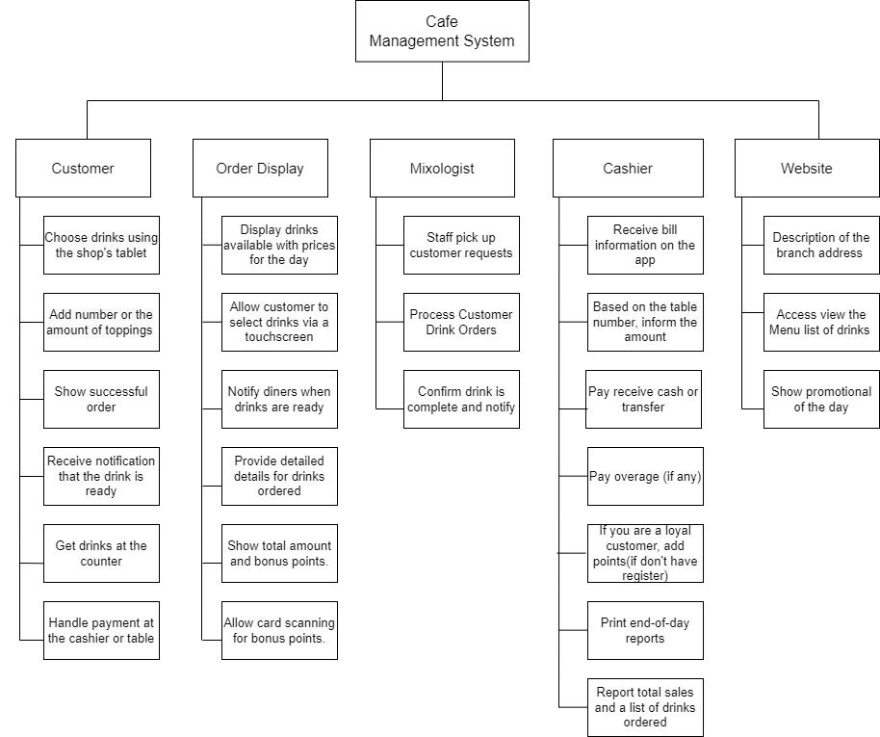

## **7.2 Context Model**

### **a) Context Model**

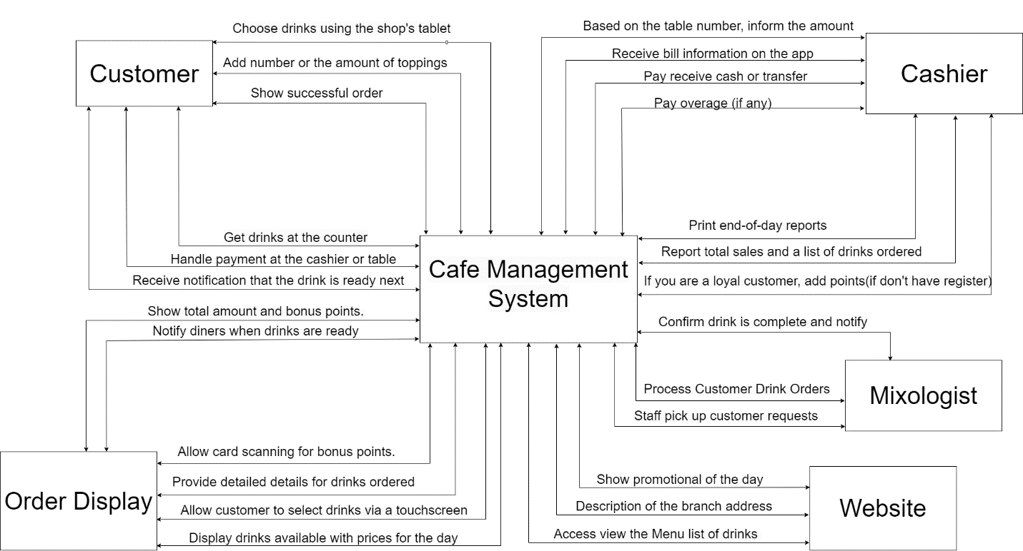

### **b) System Context Description**

|  |
| --- |
| **Order Section:**  **Functionality**: The Order Section serves as the front-end interface for customers to place their orders using touch screens. It displays the day's drink offerings along with prices, allowing diners to select their preferred drinks and specify quantities.  **Features**:  Touchscreen interface for order placement.  Notification system for drink readiness displayed on screens.  Real-time tracking of orders and bill generation.  Integration with a card reader for bonus points accrual.  Seamless transition to the cashier section for payment. |
| **Mixologist Section:**  **Functionality**: The Preparation Section manages the daily list of drinks that can be served. It handles requests from diners, displays relevant drink information, and confirms the completion of drink preparation by the bartender.  **Features**:  Daily management of drink offerings.  Order display for bartenders including drink information and quantity.  Confirmation of drink preparation status. |
| **Cashier Section:**  **Functionality**: The Cashier Section is responsible for handling transactions and finalizing the payment process. It is linked to the customer's table number, announces the amount due, processes payments, and generates end-of-day reports.  **Features**:  Table-based transaction processing.  Amount announcement, payment entry, and change calculation.  End-of-day sales reporting. |
| **Web Browsers Section:**  **Functionality**: The Web Browsers Section extends the coffee shop's reach to online visitors. It allows users to access the coffee shop's website to check daily offerings and promotions at various branches.  **Features**:  Online display of daily drink offerings.  Information on prices and promotions.  Enhances customer awareness and engagement. |

## **7.3 List of Actor**

|  |
| --- |
| **Customer:**  Interacts with the "Order Placement " to select and order drinks through a touchscreen.  Views the current bill, including ordered drinks, prepared drinks, total amount, and loyalty points.  Goes to the cashier to make payments scan or cash and may use a card to accumulate loyalty points. |
| **Mixologist:**  Receives drink orders from customers.  Views information on the screen regarding the drinks to be prepared and the quantity.  Confirms the completion of drink preparation on the system. |
| **Cashier :**  Receives information from the customer, including the table number and amount paid.  Calculates and returns change (if necessary).  Prints end-of-day reports, including total daily revenue and a list of drinks ordered. |
| **Web Browser User:**  Accesses the cafe's website to get information about the drinks served in the day at different branches. |

## **7.4. List of Use Cases**

|  |  |  |
| --- | --- | --- |
| Use case ID | Use case name | Functional Req. |
| *UC.01* | Display Menu | *FR1.1* |
| *UC.02* | Order Placement | *FR1.2* |
| *UC.03* | Order Notification | *FR1.3* |
| *UC.04* | View Current Bill | *FR1.4* |
| *UC.05* | Payment and Loyalty | *FR1.5* |
| *UC.06* | Mixologist Processing | *FR2* |
| *UC.07* | Order Payment | *FR3* |
| *UC.08* | Daily Summary | *FR3.1* |
| *UC.09* | Menu information on the website | *FR4* |

# **8. PROJECT PLAN**

References <Team3NNC.mpp>

# **9.** **TECHNICAL CONSTRAINTS**

## **9.1 Technical to develop:**

* ***Languages****: Python, Nodejs,C++, Java,HTML.*
* ***Server:*** *Socket.io*

## **9.2 Environment:**

* ***Web browsers****: Google Chrome, Molliza Firefox, Apple Safari, Cốc Cốc, Microsoft Edge.*
* ***Environment:*** *Microsoft Windows, Mac Os, Android, iOS,..*

## **9.3 Another:**

* ***Management tool****: Google Drive, Slack*
* ***Design tool****: Figma*
* ***Manage Source code tool****: Git,Github*
* ***Test tool*** *: Katalon Studio*

# **10. ANALYSIS & MODELING REQUIREMENT**

## **10.1. Use Case Diagram**

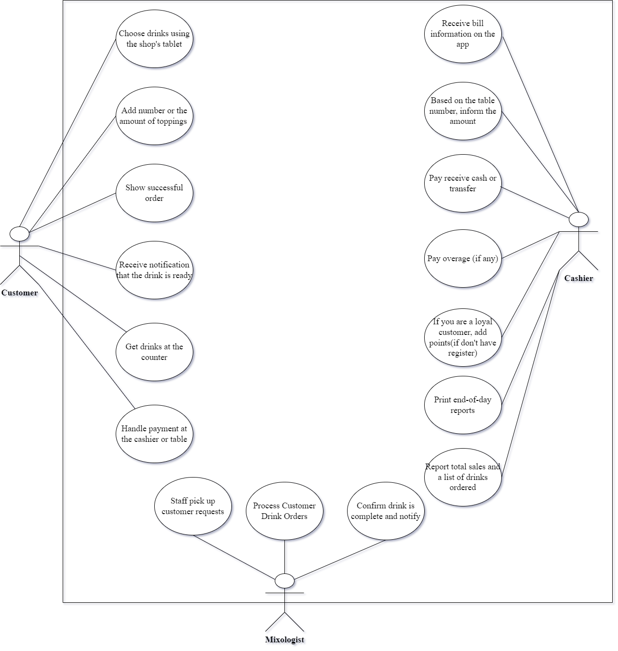

## **10.2.** **List of Business Rule**

|  |  |  |
| --- | --- | --- |
| Code | Business rules | Use case |
| *BR1* | *Customers can only view and order drinks displayed on the menu for the current day.*  *The system should update the menu daily to ensure customers have access to the latest offerings.*  *Customers can only place orders during the operating hours of the coffee shop.* | *UC.02* |
| *BR2* | *The Mixologist must confirm drink preparation on the system for each order.*  *Upon receiving an order, the Mixologist marks the drink as "in preparation" in the system.*  *Once the drink is ready, the Mixologist updates the system to indicate its prepared status.* | *UC.02* |
| *BR3* | *The cashier must announce the amount and calculate change for each customer.*  *The cashier informs the customer of the total amount due after processing the order.*  *Change is calculated accurately, and the cashier communicates it to the customer.* | *UC. 03* |
| *BR4* | *The web browser should display the current menu and daily offerings.*  *The online menu is updated in real-time to reflect any changes or additions.*  *Daily offerings include special promotions or limited-time drinks.* | *UC.04* |
| *BR5* | *The web browser should display the current menu and daily offerings.*  *The online menu is updated in real-time to reflect any changes or additions.*  *Daily offerings include special promotions or limited-time drinks.* | *UC.05* |
| *BR6* | *Bonus points are added to the customer's account when scanning their card.*  *Customers are prompted to scan their loyalty card during the payment process.*  *The system automatically adds bonus points based on the total purchase amount.* | *UC.06* |

## **10.3. Activity Diagram**

### **a) The steps performed of function abc….**

|  |  |
| --- | --- |
| **Actor Action** | **System Response** |
| **1.Place an Order** | **1.** **Save the order, notify when drinks are ready, update the bill** |
| **2.** **Drink Preparation** | **2.** **Update the status of prepared drinks** |
| **3.** **Cashier Transaction** | **3.** **Update sales record, calculate change, print end-of-day report** |
| **4.** **Web Browsing** | **4.** **Display current menu, show daily offerings** |
| **5.** **Card Scanning or cash** | **5.** **Process payment, add bonus points to the customer's account** |

### **b) Activity Diagram of function abc….**

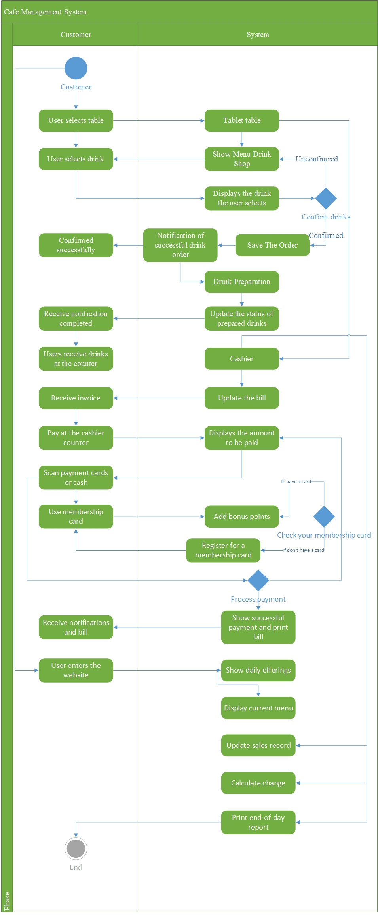

# **11. INTERFACE DESIGN**

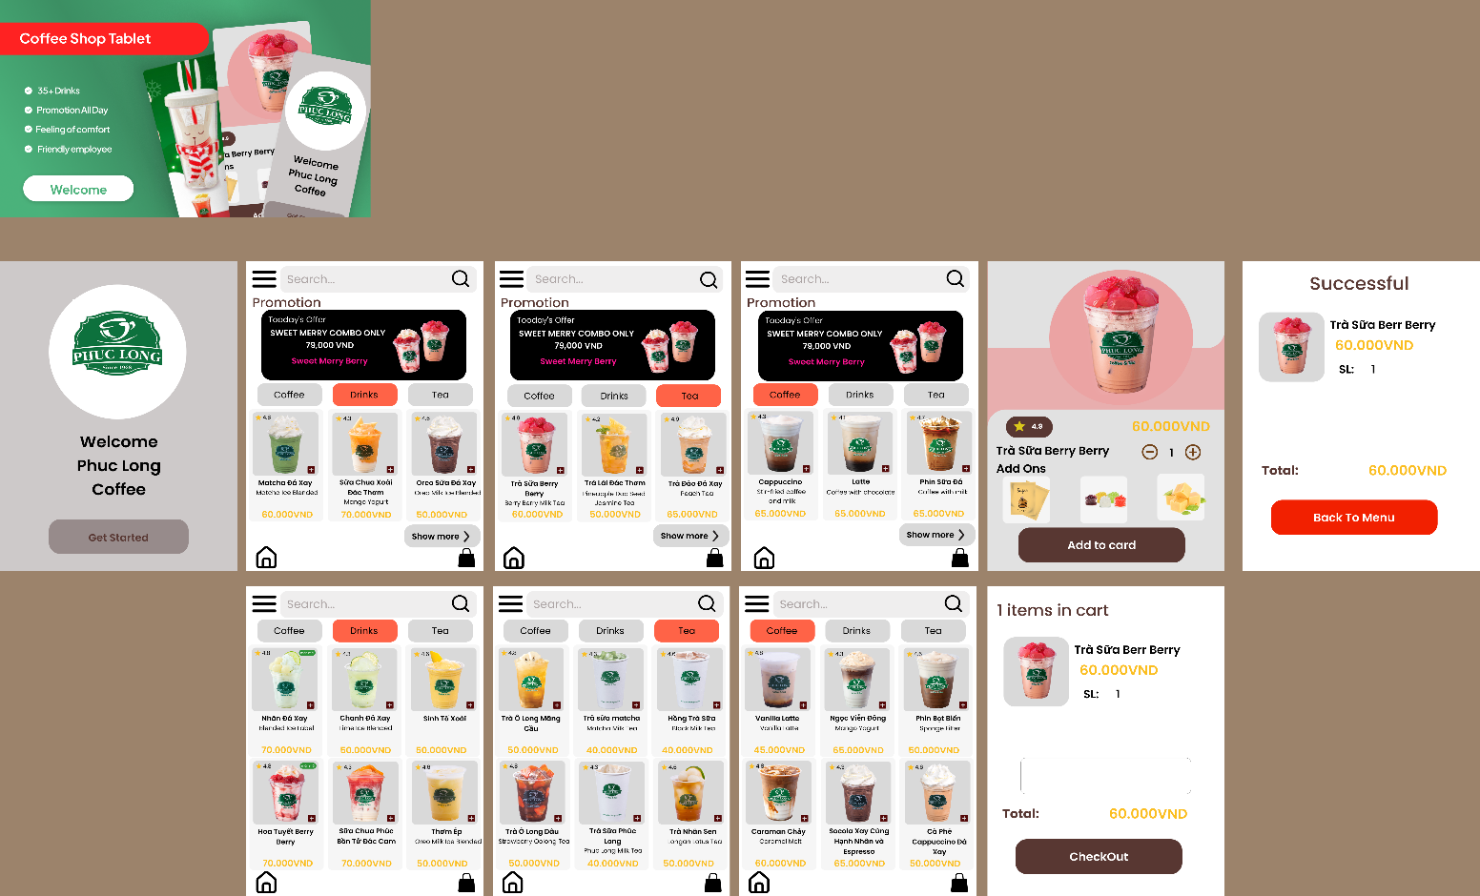

## **11.1. Introduction tool design**

Figma is a cloud-based design and prototyping tool that allows collaborative design and development. It is widely used for creating user interfaces, designing interactive prototypes, and facilitating team collaboration throughout the design process. Figma's key features include real-time collaboration, version history, and the ability to design and prototype within the same platform.

Canvas: The main working area where you create your designs.

Layers Panel: Manage and organize layers within your design.

Properties Panel: Adjust properties of selected elements.

Assets Panel: Store and reuse design components.

Creating Designs:

Use shapes, text, and drawing tools to create visual elements.

Import images and icons to enhance your design.

Utilize Figma's design constraints for responsive layouts.

## **11.2 User Interface Design for ABC Function**

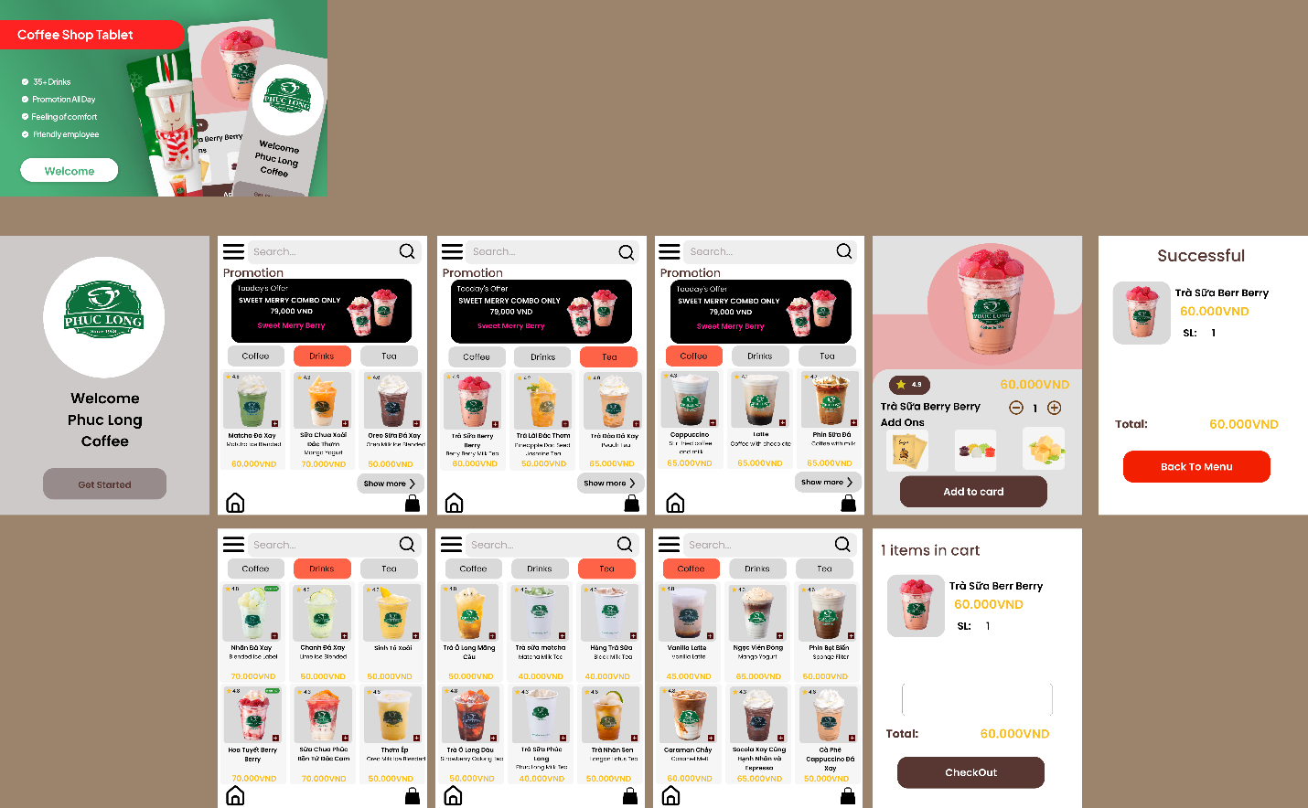

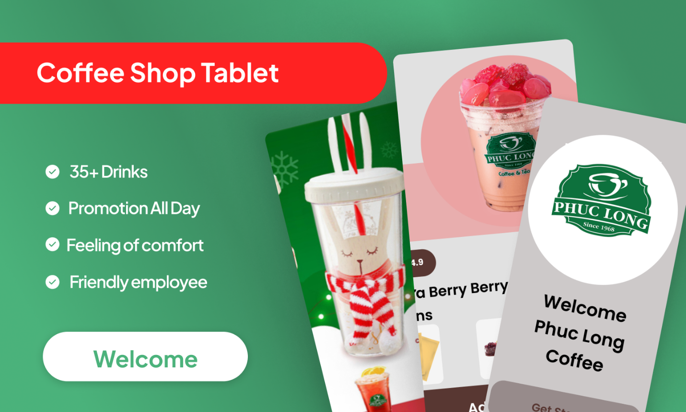

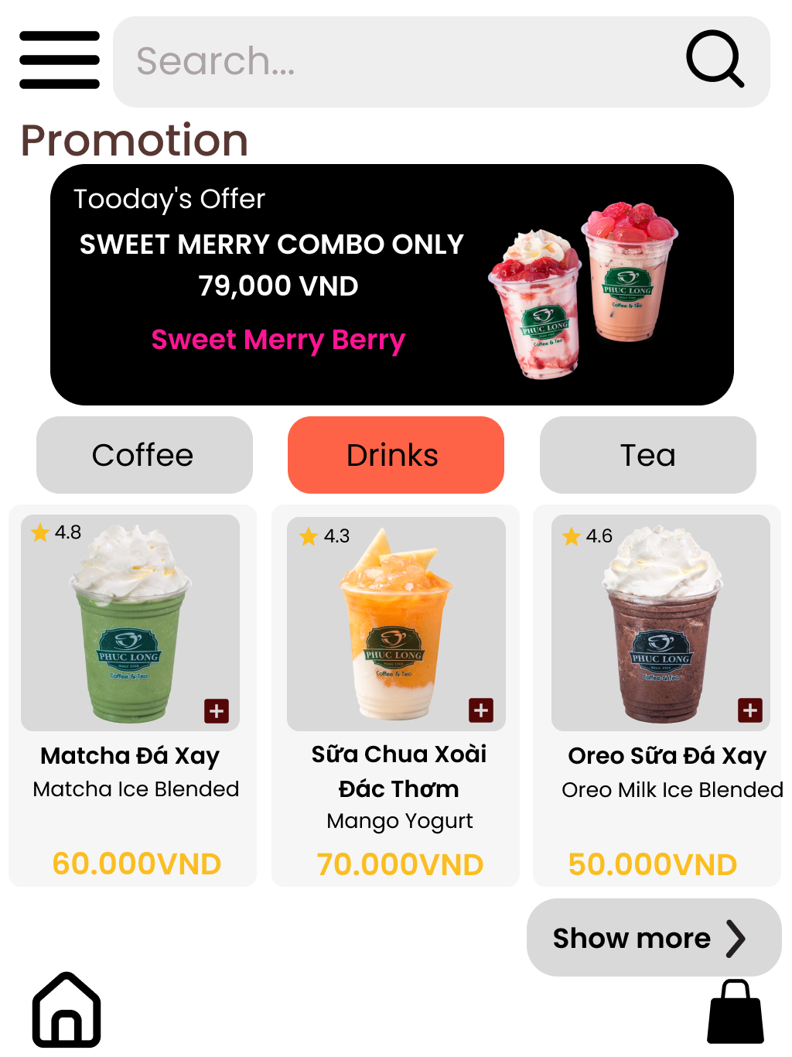

Link Test Function:

<https://www.figma.com/proto/TTBw4F8pXczDDWXiEmKQ8H/Nh%C3%B3m-3-UI-Coffe-Order?type=design&node-id=3-269&t=p9wmU3Z8FDHL4adL-0&scaling=scale-down&page-id=0%3A1&starting-point-node-id=3%3A269>

# **12. CONFIGURATION MANAGEMENT**

## **a) Introduction the tool Source Code Management**

**GitHub: Elevating Collaboration in Software Development**

GitHub, a pivotal source code management tool, seamlessly blends powerful version control with collaboration features. Built around Git, it unifies version control and collaboration, allowing developers to track changes, manage branches, and propose modifications through pull requests.

Its repository hosting structures projects efficiently, offering comprehensive containers for code history, branches, and releases. GitHub's project management tools, including project boards and milestones, enhance task organization. Developers leverage its social coding approach for community engagement, knowledge sharing, and open-source contributions.

With streamlined documentation, integration with CI/CD tools, and global reach, GitHub stands as a central hub for the software development lifecycle. It transcends version control, empowering developers and teams worldwide.

## **b) Introduction Key Functional**

***GitHub*** *is a robust source code management platform offering essential functionalities for streamlined development Main Functional*

***Project Management****: GitHub Projects and Boards aid in organizing tasks and visualizing project workflows.*

*\*There are also functions:*

***Version Control****: Efficient Git-based version control for tracking changes and managing branches.*

***Repository Management****: Centralized space for creating, cloning, and forking repositories.*

***Collaborative Tools****: Features like issues, pull requests, and discussions facilitate seamless team collaboration.*

***Community Engagement****: Encourages community participation through pull requests, code reviews, and discussions.*

**c) The Screen Shot apply Source Code Management of team**

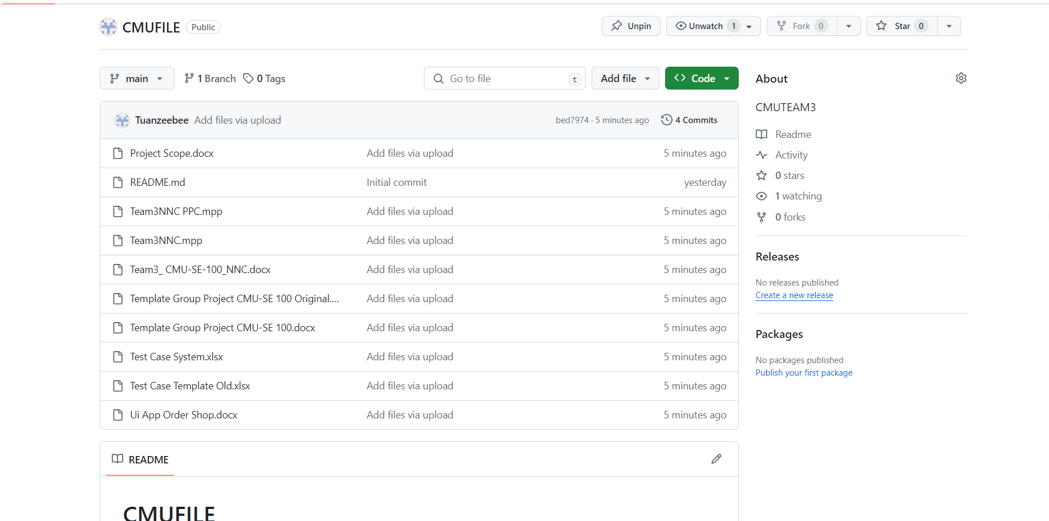

# **13. TESTING**

## **a) Introduction to method testing apply of this project**

*Introduction to Testing Methodology for the Coffee Shop Management System:*

*The testing phase is a critical component in the development lifecycle of the Coffee Shop Management System. It ensures that each module functions as intended, providing a seamless and reliable experience for both coffee shop staff and customers. The chosen testing methodology employs a comprehensive approach to verify the correctness, performance, and user-friendliness of the system. By systematically applying various testing techniques, we aim to identify and address potential issues, ensuring a robust and high-quality solution. This introduction sets the stage for a methodical testing process that aligns with the project's objectives and quality standards.*

*Introduction to User Acceptance Testing (UAT) in the Coffee Shop Management System:*

*User Acceptance Testing (UAT) plays a pivotal role in validating the Coffee Shop Management System's functionality from the end-users' perspective. This phase involves collaboration between the development team and coffee shop staff to ensure that the system aligns with operational needs and enhances efficiency. UAT aims to confirm that all user stories, including features like the touchscreen interface, order processing, and advertising displays, meet the specified requirements and deliver an optimal user experience. Through systematic testing and user feedback, UAT becomes a crucial step in fine-tuning the system to meet the coffee shop's unique operational requirements and ensuring overall user satisfaction.*

## **b) Test Cases**

[Test Case System.xlsx](Test%20Case%20System.xlsx)

# **14. CONTRIBUTION**

|  |  |  |  |  |
| --- | --- | --- | --- | --- |
| **No.** | **Participant** | **Role** | **Responsibilities** | **%**  *Mức độ (%) đóng góp cho bài tập nhóm* |
| **1** | **Nguyễn Đình Tuấn** | **TeamLeader** | **Làm mục 9 10.3 11 12** |  |
| **2** | **Lê Hữu Quyền** | **Teammember** | **7.1-7.2** |  |
| **3** | **Nguyễn Đình Phi** | **Teammember** | **10.1-10.2** |  |
| **4** | **Thân Quang Huy** | **Teammember** | **6.3 a,b** |  |
| **5** | **Trần Nguyễn Hữu Trọng** | **Teammember** | **7.3-7.4** |  |